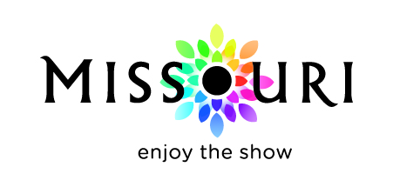 | Cooperative Marketing  Missouri Division of Tourism  FY2021 Program Calendar

September 2019
06 – FY21 DMO Certification applications posted on website

November 2019
01 – FY21 DMO Certification applications due by 5 pm

December 2019
13 – FY21 DMO Certification and CTL letter mailed

February 2020
21 – FY21 Approved Media/Markets List posted on webpage
21 – FY21 Marketing Platform Development (MPD) guidelines posted on webpage
21 – FY21 Marketing Matching Grant (MMG) guidelines posted on webpage

March 2020
01 – Online database goes live
01 – FY21 MPD applications open
16 – FY21 MMG applications open

April 2020
15 – FY21 MPD applications due by 5 pm

May 2020
15 – FY21 MMG applications due by 5 pm

June 2020
15 – FY21 MMG & MPD funding announced

July 2020
01 – FY21 Program Year Begins

November 2020
27 – FY21 1st MMG Quarterly Report postmark due date

February 2021
26 – FY21 2nd MMG Quarterly Report postmark due date

May 2021
28 – FY21 3rd MMG Quarterly Report postmark due date

June 2021
30 – FY20 Program Year Ends

August 2021
27 – FY21 Final MMG & MPD Quarterly Report postmark due date

December 2021
03 – FY21 MMG Project Summary Report postmark due date

