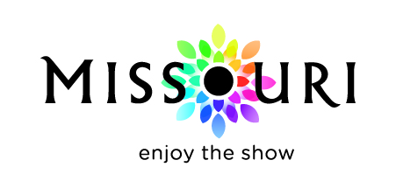 | Promote Missouri Fund Program  Missouri Division of Tourism  Marketing Pre-Approval Form

Ad and Materials Artwork/Design Approval Form

Instructions: Complete sections A and B below. Fax, email or mail completed approval request form along with product sample/proof to be approved to MDT. Please allow five business days for approval.

SECTION A:

TO: PMF Team Missouri Division of Tourism From:
Date:

SECTION B:

DMO Name: Contract #:
Media Type: Choose a Media Type
Budget Grid Line Item #:
Ad Size/Color:
Placement Dates:
Publications/Markets:
Landing Page URL:
Description of Activity (if digital):

SECTION C:
Response to Approval Request

Date:
To:
From: Missouri Division of Tourism

MDT COMMENTS

The ads, artwork, materials design, etc. described above and submitted with this approval request meet the Division of Tourism guidelines for reimbursement through the Promote Missouri Fund Program with regard to content and logo requirements. This approval does not address any changes to the approved marketing project, such as dates, publications or marketing activities.

MDT Approval Signature #1 MDT Approval Signature #2

