FY2019
Cooperative Marketing
Marketing Platform Development Program & Report Guide
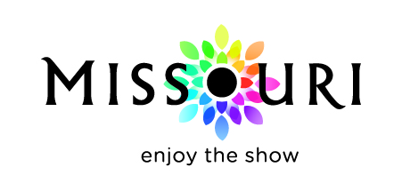

.

Published February 2018 for the FY2019 program year - July 1, 2018, through June 30, 2019

Missouri Division of Tourism
301 West High Street, Room 290
Jefferson City, MO 65101
573-526-5900

Governor Mike Parson

Missouri Tourism Commission
Scott Hovis, Chairman
Lt. Governor Mike Kehoe
Senator David Sater
Senator Gina Walsh
Representative
Representative Pat Conway
David Corley
Eric Rhone
Jay Wasson
Kurt Witzel

Director Ward Franz

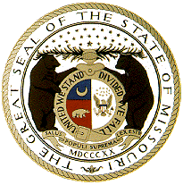

Missouri Tourism Regions
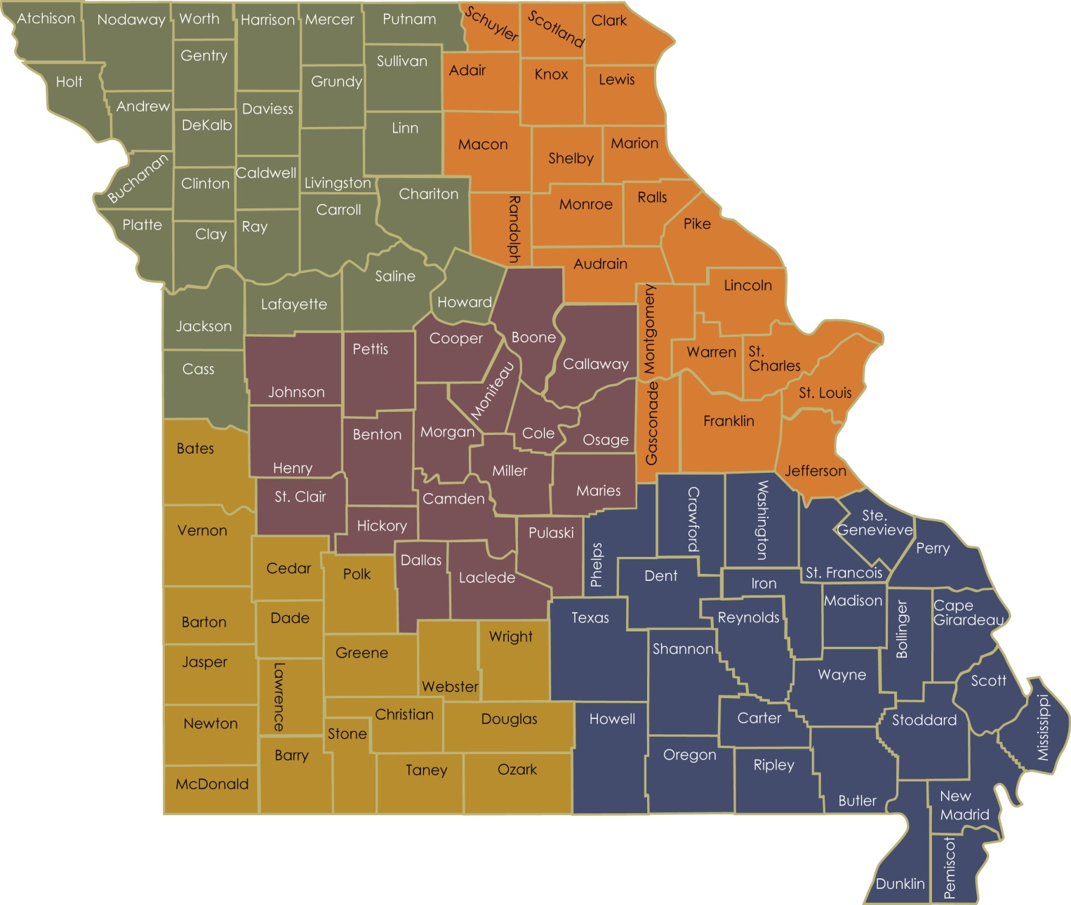

The Missouri Division of Tourism (MDT) partners with Destination Marketing Organizations (DMOs) across the state to advertise and promote Missouri’s vast array of tourism assets. The Division’s Cooperative Marketing Programs invests in projects that are specifically designed to increase visitation and visitor spending throughout the state.
In order to reach the goals established in the MDT strategic plan, the goals and executions of the Cooperative Marketing are aligned with MDT’s overall strategic goals. Funds are distributed among two separate matching grant programs, the Marketing Matching Grant and the Marketing Platform Development Grant.
The MDT will fund qualified advertising and marketing projects to achieve the following objectives:
- Support and further MDT’s overall marketing strategy as outlined in the annual marketing plan and position Missouri to compete more effectively for travel and tourism market share.
- Create programs based on the common marketing goals of MDT and the DMO, thereby creating mutually beneficial marketing executions.
- Maintain programs that are efficient to implement for both MDT and its partners.

Marketing Platform Development Overview
The Marketing Platform Development (MPD) program is designed for a one-time marketing platform investment that will be used beyond the fiscal year of the initial investment. Approved projects are reimbursed at up to 50 percent of the approved application amount and provide for development, improvement or expansion of tourism marketing programs and products.

Administration
The MDT administers the Cooperative Marketing Programs on behalf of the Missouri Tourism Commission, which reserves the right to make all final decisions.

Promote Missouri Fund Advisory Committee (PMFAC) - The advisory committee is comprised of 10 tourism industry professionals representing each of the five regions of the state, providing valuable customer input about program design and administration of the program.

Appeal process – The participating DMO may file an appeal to the PMFAC regarding issues of eligibility and compliance. Appeals must be directed to Cooperative Marketing in writing and must contain an explanation of the basis for the appeal. With recommendations from the PMFAC, MDT will review the appeal and provide a ruling. Guideline requirements may not be appealed.

Address: Missouri Division of Tourism
Cooperative Marketing
301 W. High St., Room 290
Jefferson City, MO 65101

Phone number: 573-751-4133
Email: MDTCoop@ded.mo.gov
Website: Industry.VisitMO.com

Disclosures
- The State of Missouri reserves the right to review/audit the participant’s contract records for a period of five years after the close of the contract period.
- MDT may terminate any contract upon discovery of a violation of any terms and/or requirements of the contract committed by the participant.
- Failure to complete an approved project may result in a one-year disqualification from participation in the programs. In some situations, partial completion of a project or the completion of a project vastly altered from the approved project may result in the withholding of approved funds.
- Failure to complete a project as agreed to will be a consideration in the evaluation of future applications.
- The Missouri Tourism Commission reserves the right to make all final decisions concerning the administration of this program.

MPD Participation
Eligibility
MPD is available to MDT-certified DMOs with a County Tourism Level (CTL) 1-4, non-certified DMOs and regional partnerships. For DMO information, please refer to the current DMO Guidelines.

All participants to be reimbursed by the MPD program must be registered as a vendor through the State of Missouri’s Statewide eProcurement System. An electronic funds transfer is required. For more information, or to sign up, visit https://missouribuys.mo.gov.

Program Application
The maximum funding per platform/application is $5,000 per applicant. No applicant may receive more than one MPD grant per fiscal year; no applicant may receive funding for a platform for which they received funding in a prior year.

Completed program applications are due at MDT’s Jefferson City office by the dates and times listed on the fiscal year program calendar. Applications arriving late will not be considered for funding. MDT reviews the MPD applications on a pass/fail basis for completeness and program compliance. Applications and instructions are available on the website.

Bids - Follow your internal procurement policy.

E-Verify- Participants in the MPD program are subject to section 285.530, RSMo, which states:
- No business entity or employer shall knowingly employ, hire for employment, or continue to employ an unauthorized alien to perform work within the state of Missouri.
- As a condition for the award of any contract or grant in excess of five thousand dollars by the state or by any political subdivision of the state to a business entity, or for any business entity receiving a state-administered or subsidized tax credit, tax abatement, or loan from the state, the business entity shall, by sworn affidavit and provision of documentation, affirm its enrollment and participation in a federal work authorization program with respect to the employees working in connection with the contracted services. Every such business entity shall sign an affidavit affirming that it does not knowingly employ any person who is an unauthorized alien in connection with the contracted services. Any entity contracting with the state or any political subdivision of the state shall only be required to provide the affidavits required in this subsection to the state and any political subdivision of the state with which it contracts, on an annual basis. During or immediately after an emergency, the requirements of this subsection that a business entity enroll and participate in a federal work authorization program shall be suspended for fifteen working days. As used in this subsection, “emergency” includes the following natural and manmade disasters: major snow and ice storms, floods, tornadoes, severe weather, earthquakes, hazardous material incidents, nuclear power plant accidents, other radiological hazards, and major mechanical failures of a public utility facility.
- All public employers shall enroll and actively participate in a federal work authorization program.
- An employer may enroll and participate in a federal work authorization program and shall verify the employment eligibility of every employee in the employer’s hire whose employment commences after the employer enrolls in a federal work authorization program. The employer shall retain a copy of the dated verification report received from the federal government. Any business entity that participates in such program shall have an affirmative defense that such business entity has not violated subsection 1 of this section.
- A general contractor or subcontractor of any tier shall not be liable under sections 285.525 to 285.550 when such general contractor or subcontractor contracts with its direct subcontractor who violates subsection 1 of this section, if the contract binding the contractor and subcontractor affirmatively states that the direct subcontractor is not knowingly in violation of subsection 1 of this section and shall not henceforth be in such violation and the contractor or subcontractor receives a sworn affidavit under the penalty of perjury attesting to the fact that the direct subcontractor’s employees are lawfully present in the United States.

Affidavit of Work Authorization and Documentation - Pursuant to section 285.530, RSMo, if the contractor meets the section 285.525, RSMo, definition of a “business entity” (http://www.moga.mo.gov/statutes/C200-299/2850000525.HTM), the contractor must affirm the contractor’s enrollment and participation in the E-Verify federal work authorization program with respect to the employees hired after enrollment in the program who are proposed to work in connection with the services requested herein. The contractor should complete applicable portions of the Business Entity Certification, Enrollment Documentation, and Affidavit of Work Authorization Exhibit. The applicable portions of Exhibit must be submitted prior to an award of a contract.
Contractor’s Personnel - The contractor shall only employ personnel authorized to work in the United States in accordance with applicable federal and state laws. This includes but is not limited to the Illegal Immigration Reform and Immigrant Responsibility Act (IIRIRA) and INA Section 274A.
If the contractor is found to be in violation of this requirement or the applicable state, federal and local laws and regulations, and if the State of Missouri has reasonable cause to believe that the contractor has knowingly employed individuals who are not eligible to work in the United States, the state shall have the right to cancel the contract immediately without penalty or recourse and suspend or debar the contractor from doing business with the state. The state may also withhold up to twenty-five percent of the total amount due to the contractor.
The contractor shall agree to fully cooperate with any audit or investigation from federal, state or local law enforcement agencies.
If the contractor meets the definition of a business entity as defined in section 285.525, RSMo, pertaining to section 285.530, RSMo, the contractor shall maintain enrollment and participation in the E-Verify federal work authorization program with respect to the employees hired after enrollment in the program who are proposed to work in connection with the contracted services included herein. If the contractor’s business status changes during the life of the contract to become a business entity as defined in section 285.525, RSMo, pertaining to section 285.530, RSMo, then the contractor shall, prior to the performance of any services as a business entity under the contract:
(1) Enroll and participate in the E-Verify federal work authorization program with respect to the employees hired after enrollment in the program who are proposed to work in connection with the services required herein; AND
(2) Provide to the Missouri Division of Tourism the documentation required in the exhibit titled, Business Entity Certification, Enrollment Documentation, and Affidavit of Work Authorization Exhibit affirming said company’s/individual’s enrollment and participation in the E-Verify federal work authorization program; AND
(3) Submit to the Missouri Division of Tourism a completed, notarized Affidavit of Work Authorization provided in the exhibit titled, Business Entity Certification, Enrollment Documentation, and Affidavit of Work Authorization Exhibit.
In accordance with subsection 2 of section 285.530, RSMo, the contractor should renew their Affidavit of Work Authorization annually. A valid Affidavit of Work Authorization is necessary to award any new contracts.
Subcontractors - Any subcontracts for the products/services described herein must include appropriate provisions and contractual obligations to ensure the successful fulfillment of all contractual obligations agreed to by the contractor and the State of Missouri and to ensure that the State of Missouri is indemnified, saved and held harmless from and against any and all claims of damage, loss and cost (including attorney fees) of any kind related to a subcontract in those matters described in the contract between the State of Missouri and the contractor. The contractor shall expressly understand and agree that he/she shall assume and be solely responsible for all legal and financial responsibilities related to the execution of a subcontract. The contractor shall agree and understand that utilization of a subcontractor to provide any of the products/services in the contract shall in no way relieve the contractor of the responsibility for providing the products/services as described and set forth herein.
Pursuant to subsection 1 of section 285.530, RSMo, no contractor or subcontractor shall knowingly employ, hire for employment or continue to employ an unauthorized alien to perform work within the state of Missouri. In accordance with sections 285.525 to 285.550, RSMo, a general contractor or subcontractor of any tier shall not be liable when such contractor or subcontractor contracts with its direct subcontractor who violates subsection 1 of section 285.530, RSMo, if the contract binding the contractor and subcontractor affirmatively states that
- the direct subcontractor is not knowingly in violation of subsection 1 of section 285.530, RSMo, and
- shall not henceforth be in such violation and
- the contractor or subcontractor receives a sworn affidavit under the penalty of perjury attesting to the fact that the direct subcontractor’s employees are lawfully present in the United States.

Awards
Award notification letters are emailed to the Applicant’s President/CEO and Applicant’s Project Director (listed on the application) prior to the beginning of the project period.

The Cooperative Marketing Program budget amounts are tied to the annual funding MDT received from the General Assembly. Therefore, allocations may change from the original estimate if MDT’s budget is changed mid-year. The number of certified DMOs and the CTLs also have an impact on the maximum funding amounts and may cause budgets to change. While MDT makes every effort to ensure Applicants are awarded the proposed funding, those levels may need to be modified at a later date.

Review Process – The MPD program has a limited amount of funding available – in FY19, the total MPD funding for all platforms cannot exceed $30,000. MDT and the PMFAC will review the applications on a pass/fail basis for completeness and program compliance. Amounts of match will be awarded based on the available budget, number of partners applying and quality of the application.

Marketing Platforms
The following FY19 MPD projects are eligible for reimbursement:

Brand Awareness Study
MDT will assist industry partners in the funding of a Brand Awareness Study. A brand awareness study (and analysis) can give a measurement of which consumers are familiar with the brand and product. How much of the target market is aware of the brand? Understanding this information can enable you to market more efficiently and effectively.

Creative Design
It is important that tourism industry organizations have a strong memorable identity for the brand through image marketing. Much of the advertising communication is centered on this creative and/or logo. Participants may contract with an agency to develop a logo or to design base creative ads.

Creative Strategy
Participants may contract with an ad agency or marketing communication agency to develop a creative strategy. The contracted agency will evaluate the marketing and promotional situation to determine what needs to be communicated to the marketer’s target audience. A strong memorable identity for the brand through image marketing communication will be developed.

Marketing Plan Development
A strong marketing plan is crucial to running a successful marketing campaign. Participants may contract through an agency to layout the advertising and marketing objectives specific to the needs of the organization. A marketing plan must be clear before the creative strategy can be determined.

Marketing Strategy
Develop a marketing strategy to ensure the marketing plan, social media, creative, website, research, and visual assets all work together to form a cohesive identity for the destination. Participants can contact with an organization to determine the needs and/or execute the needs of the marketing strategy.

Mobile Optimization
If your website is not yet optimized for mobile, consider a responsive web design. A responsive web design enables your website to react to a user’s actions and detects the medium where the site is currently being watched in order to provide the best experience possible to the user in terms of navigability and readability.

Social Media Strategy
Develop a social media strategic plan to determine which social network connects you with your target audience, determine best content types and outreach tactics, and reach targeted followers that generate more qualified leads for your organization. Participants may contract with a social media strategist to develop a strategy that includes: research and discovery, strategy development, implementation planning and measurement.

Visitor Profile Study
MDT will assist industry partners in the funding of a Visitor Profile Study. This research provides you a profile of your visitor based on demographic and behavioral characteristics such as age, income, size of travel party, activities and expenditures. Understanding this information will enable you to market to your target audience more efficiently and effectively.

Visual Asset Procurement
Strong visuals in marketing are vital. Because of this, MDT will assist industry partners in procuring visual assets. Participants may contract with a professional photographer and/or a videographer to build your visual asset library for marketing purposes.

Website Development
Design or upgrade your tourism website to include focused calls-to-action, enhanced images and simplified navigation to allow your visitors to find the information quickly and easily. Participants may contract with a web designer to update their site.

MPD Requirements
For eligibility, all activities and components are subject to the following:
- All funded marketing activities must take place, expenses must be incurred, the product delivered or service provided, and the project completed between July 1 and June 30 of the fiscal year.
- Products that fall outside the established fiscal year will not be reimbursed.
- Funds from other Missouri state sources may not be used to satisfy the Applicant’s matching funds obligation.
- Activities must be completed as approved in the contract or a subsequently approved revision.

Logo Usage
Funded platforms must display the official Missouri tourism logo and/or credit line on all funded products, according to the specifications described in the Missouri Style Guide. The Style Guide can be found on the website. To request the usage of the MDT logo on materials outside the Cooperative Marketing Program, please see the website for more details.

MPD Reimbursement Requirements
Reimbursement and Reporting
Only one request for reimbursement is allowed per Applicant under the MPD grant program. The Reimbursement Request/Project Summary Report and copies of the grant project (example: social media strategic plan, creative strategy, profile study) must be submitted within 60 days following the completion of the project. All participants with an approved MPD contract will receive reimbursements through electronic funds transfers. Grant funds and the participant’s match must be used in accordance with the approved application. Forms are available on the website.

Basic Requirements for Reimbursement
The participant must first incur the approved expense and pay at least one-half of each invoice amount prior to submitting the expense to MDT for reimbursement. Invoices submitted for reimbursement must be for expenses approved in the MPD application. To qualify for reimbursement, expenses must be incurred within the contract period and the funded platform must be completed. Platforms that require the MDT logo to be displayed must be approved in advance by MDT for logo compliance before going live.
All reimbursements must include a proof of expense, proof of payment and the proof of performance.

Proof of expense (invoice) is required for each service provided.
- The invoice must show the participant as the “bill to” organization, contain the name and address of the vendor providing the service, provide an itemized detail of the service provided (including dates of service or date cost incurred), and include the total cost.
- When services are provided through an advertising agency, an invoice is required from the vendor to the ad agency AND an invoice from the ad agency to the participant for each expense.

Proof of the participant’s payment is required.
- Checks must be written from the participants’ account for at least 50 percent of the charge for the service invoiced. If the check covers more than one expense, include a copy of the check detail.
- Credit card payments must include a copy of the credit card statement detailing the reimbursable expense. All other expenses must be redacted from the statement.
- When services are provided through an advertising agency, proof of payment from the participant to the ad agency AND proof of payment from the ad agency to the vendor must be submitted.

Proof of performance is required – different documentation is required depending on the platform of the project, for example:
- Website design will require final website design approval before going live
- Social Media Strategy will require a copy of the actual strategy that was developed
- Research platforms will require copies of the research study that was completed.

