FY2019
Cooperative Marketing
Marketing Matching Grant
Program & Reports Guide
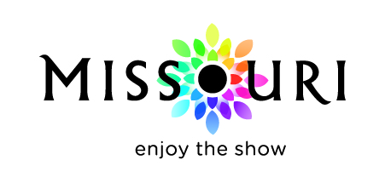

.

Published February 2018 for the FY2019 program year - July 1, 2018, through June 30, 2019

Missouri Division of Tourism
301 West High Street, Room 290
Jefferson City, MO 65101
573-526-5900

Governor Mike Parson

Missouri Tourism Commission
Scott Hovis, Chairman
Lt. Governor Mike Kehoe
Senator David Sater
Senator Gina Walsh
Representative
Representative Pat Conway
David Corley
Eric Rhone
Jay Wasson
Kurt Witzel

Director Ward Franz

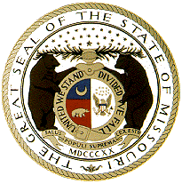

Missouri Tourism Regions
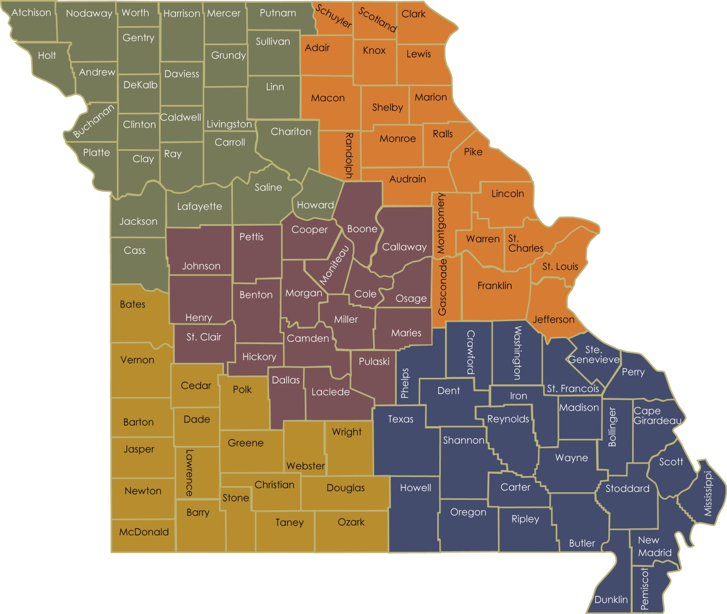

The Missouri Division of Tourism (MDT) partners with Destination Marketing Organizations (DMOs) across the state to advertise and promote Missouri’s vast array of tourism assets. The Division’s Cooperative Marketing Programs invests in projects that are specifically designed to increase visitation and visitor spending throughout the state.
In order to reach the goals established in the MDT strategic plan, the goals and executions of Cooperative Marketing are aligned with MDT’s overall strategic goals. Funds are distributed among two separate matching grant programs, the Marketing Matching Grant and the Marketing Platform Development Program.
The MDT will fund qualified advertising and marketing projects to achieve the following objectives:
- Support and further MDT’s overall annual marketing strategy as outlined in the annual marketing plan and position Missouri to compete more effectively for travel and tourism market share during the next decade.
- Create programs based on the common marketing goals of MDT and the DMO, thereby creating mutually beneficial marketing executions.
- Create a program that is efficient to implement for both MDT and its partners.

Marketing Matching Grant Overview

The Marketing Matching Grant (MMG) is designed to primarily target the leisure traveler and reimburse up to 50 percent of a DMO's approved media project. The match of state funds, provides a meaningful financial incentive to participants and a significant economic benefit to the State of Missouri.

Administration
The MDT administers the Cooperative Marketing Programs on behalf of the Missouri Tourism Commission, which reserves the right to make all final decisions.

Promote Missouri Fund Advisory Committee (PMFAC) - The advisory committee is comprised of 10 tourism industry professionals representing each of the five regions of the state, providing valuable customer input about program design and administration of the program.

Appeal process – The participating certified DMO may file an appeal to the PMFAC regarding issues of eligibility and compliance. Appeals must be directed to the MDT Cooperative Marketing Program in writing and must contain an explanation of the basis for the appeal. With recommendations from the PMFAC, MDT will review the appeal and provide a ruling. Guideline requirements may not be appealed.

Address: Missouri Division of Tourism
Cooperative Marketing
301 W. High St., Room 290
Jefferson City, MO 65101

Phone number: 573-751-4133
Email: MDTCoop@ded.mo.gov
Website: Industry.VisitMO.com

Disclosures
- The State of Missouri reserves the right to review/audit participant’s contract records for a period of five years after the close of the contract period.
- MDT may terminate any contract upon discovery of a violation of any terms and/or requirements of the contract committed by the participant.
- Failure to complete an approved project may result in a one-year disqualification from participation in the programs. In some situations, partial completion of a project or the completion of a project vastly altered from the approved project may result in the withholding of approved funds.
- Failure to complete a project as agreed to will be a consideration in the evaluation of future applications.
- The Missouri Tourism Commission reserves the right to make all final decisions concerning the administration of this program.

MMG Participation

DMO Eligibility
MMG is available to all MDT-certified DMOs. See the FY19 DMO Guidelines for additional information. The DMO certification application and required documentation are available on the website.

All DMOs to be reimbursed by the MMG must be registered as a vendor through the State of Missouri’s Statewide eProcurement System. An electronic funds transfer is required. For more information, or to sign up, visit https://missouribuys.mo.gov.

Program Application
Completed program applications and project budget grids are due at MDT’s Jefferson City office by the dates and times listed on the fiscal year program calendar. Applications arriving late will not be considered for funding. MDT reviews the MMG applications on a pass/fail basis for completeness and program compliance. Applications, budget grids and instructions are available on the website.

Bids – Follow your internal procurement policy.

E-Verify- DMOs participating in the MMG program are subject to section 285.530, RSMo, which states:
- No business entity or employer shall knowingly employ, hire for employment, or continue to employ an unauthorized alien to perform work within the state of Missouri.
- As a condition for the award of any contract or grant in excess of five thousand dollars by the state or by any political subdivision of the state to a business entity, or for any business entity receiving a state-administered or subsidized tax credit, tax abatement, or loan from the state, the business entity shall, by sworn affidavit and provision of documentation, affirm its enrollment and participation in a federal work authorization program with respect to the employees working in connection with the contracted services. Every such business entity shall sign an affidavit affirming that it does not knowingly employ any person who is an unauthorized alien in connection with the contracted services. Any entity contracting with the state or any political subdivision of the state shall only be required to provide the affidavits required in this subsection to the state and any political subdivision of the state with which it contracts, on an annual basis. During or immediately after an emergency, the requirements of this subsection that a business entity enroll and participate in a federal work authorization program shall be suspended for fifteen working days. As used in this subsection, “emergency” includes the following natural and manmade disasters: major snow and ice storms, floods, tornadoes, severe weather, earthquakes, hazardous material incidents, nuclear power plant accidents, other radiological hazards, and major mechanical failures of a public utility facility.
- All public employers shall enroll and actively participate in a federal work authorization program.
- An employer may enroll and participate in a federal work authorization program and shall verify the employment eligibility of every employee in the employer’s hire whose employment commences after the employer enrolls in a federal work authorization program. The employer shall retain a copy of the dated verification report received from the federal government. Any business entity that participates in such program shall have an affirmative defense that such business entity has not violated subsection 1 of this section.
- A general contractor or subcontractor of any tier shall not be liable under sections 285.525 to 285.550 when such general contractor or subcontractor contracts with its direct subcontractor who violates subsection 1 of this section, if the contract binding the contractor and subcontractor affirmatively states that the direct subcontractor is not knowingly in violation of subsection 1 of this section and shall not henceforth be in such violation and the contractor or subcontractor receives a sworn affidavit under the penalty of perjury attesting to the fact that the direct subcontractor’s employees are lawfully present in the United States.

Affidavit of Work Authorization and Documentation - Pursuant to section 285.530, RSMo, if the contractor meets the section 285.525, RSMo, definition of a “business entity” (http://www.moga.mo.gov/statutes/C200-299/2850000525.HTM), the contractor must affirm the contractor’s enrollment and participation in the E-Verify federal work authorization program with respect to the employees hired after enrollment in the program who are proposed to work in connection with the services requested herein. The contractor should complete applicable portions of the Business Entity Certification, Enrollment Documentation, and Affidavit of Work Authorization Exhibit. The applicable portions of Exhibit must be submitted prior to an award of a contract.
Contractor’s Personnel - The contractor shall only employ personnel authorized to work in the United States in accordance with applicable federal and state laws. This includes but is not limited to the Illegal Immigration Reform and Immigrant Responsibility Act (IIRIRA) and INA Section 274A.
If the contractor is found to be in violation of this requirement or the applicable state, federal and local laws and regulations, and if the State of Missouri has reasonable cause to believe that the contractor has knowingly employed individuals who are not eligible to work in the United States, the state shall have the right to cancel the contract immediately without penalty or recourse and suspend or debar the contractor from doing business with the state. The state may also withhold up to 25 percent of the total amount due to the contractor.
The contractor shall agree to fully cooperate with any audit or investigation from federal, state or local law enforcement agencies.
If the contractor meets the definition of a business entity as defined in section 285.525, RSMo, pertaining to section 285.530, RSMo, the contractor shall maintain enrollment and participation in the E-Verify federal work authorization program with respect to the employees hired after enrollment in the program who are proposed to work in connection with the contracted services included herein. If the contractor’s business status changes during the life of the contract to become a business entity as defined in section 285.525, RSMo, pertaining to section 285.530, RSMo, then the contractor shall, prior to the performance of any services as a business entity under the contract:
(1) Enroll and participate in the E-Verify federal work authorization program with respect to the employees hired after enrollment in the program who are proposed to work in connection with the services required herein; AND
(2) Provide to the Missouri Division of Tourism the documentation required in the exhibit titled, Business Entity Certification, Enrollment Documentation, and Affidavit of Work Authorization Exhibit affirming said company’s/individual’s enrollment and participation in the E-Verify federal work authorization program; AND
(3) Submit to the Missouri Division of Tourism a completed, notarized Affidavit of Work Authorization provided in the exhibit titled, Business Entity Certification, Enrollment Documentation, and Affidavit of Work Authorization Exhibit.
In accordance with subsection 2 of section 285.530, RSMo, the contractor should renew their Affidavit of Work Authorization annually. A valid Affidavit of Work Authorization is necessary to award any new contracts.
Subcontractors - Any subcontracts for the products/services described herein must include appropriate provisions and contractual obligations to ensure the successful fulfillment of all contractual obligations agreed to by the contractor and the State of Missouri and to ensure that the State of Missouri is indemnified, saved and held harmless from and against any and all claims of damage, loss and cost (including attorney fees) of any kind related to a subcontract in those matters described in the contract between the State of Missouri and the contractor. The contractor shall expressly understand and agree that he/she shall assume and be solely responsible for all legal and financial responsibilities related to the execution of a subcontract. The contractor shall agree and understand that utilization of a subcontractor to provide any of the products/services in the contract shall in no way relieve the contractor of the responsibility for providing the products/services as described and set forth herein.
Pursuant to subsection 1 of section 285.530, RSMo, no contractor or subcontractor shall knowingly employ, hire for employment, or continue to employ an unauthorized alien to perform work within the state of Missouri. In accordance with sections 285.525 to 285.550, RSMo, a general contractor or subcontractor of any tier shall not be liable when such contractor or subcontractor contracts with its direct subcontractor who violates subsection 1 of section 285.530, RSMo, if the contract binding the contractor and subcontractor affirmatively states that
- the direct subcontractor is not knowingly in violation of subsection 1 of section 285.530, RSMo, and
- shall not henceforth be in such violation and
- the contractor or subcontractor receives a sworn affidavit under the penalty of perjury attesting to the fact that the direct subcontractor’s employees are lawfully present in the United States.

Partnerships
A certified DMO is responsible for working with tourism organizations and businesses to promote tourism on a countywide basis. Although MDT is the primary partner of the DMO, the Division also supports additional financial partnerships. Upon entering into a financial agreement(s), it is recommended the participating certified DMO share MMG guidelines, requirements and updates with their partner(s) to ensure program compliance and foster transparency.

MDT will not be communicating with the partners of the certified DMO concerning the project. All project communication (media, ads, policy, etc.) must be between MDT and the participating, certified DMO. The DMO must provide one primary contact, referred to as the “Project Director.” However, it is important that the DMO provide both the President/CEO and the Project Director’s contact information and that must be two different individuals. Any change to the DMO’s President/CEO or the Project Director requires completion of a Key Personnel Change Form. It is imperative that MDT has the most current contact information at all times. You may request this form by contacting the cooperative marketing team.

Awards
Award notification letters are emailed to the DMO President/CEO and DMO Project Director (listed on the application) prior to the beginning of the project period.

The Cooperative Marketing budget amounts are tied to the annual funding MDT received from the General Assembly. Therefore, the allocations may change from the original estimate if MDT’s budget is changed mid-year. The number of certified DMOs and the County Tourism Levels (CTLs) also have an impact on the maximum funding amounts and may cause budgets to change. While MDT makes every effort to ensure DMOs are awarded the proposed funding, those levels may need to be modified at a later date.

County Tourism Level
Grant allocations are awarded based on the CTL calculated for each Missouri county. The CTL formula considers limited tourist expenditures, lodging expenditures, tourism employment, state parks with overnight opportunities and the level of grant funding awarded in the previous three years. CTLs are updated annually to reflect changes in the economic position of the county and all data are collected from state agencies.

Allocation
*Highlighted listings are FY19 certified DMOs
County Tourism Level (CTL) | FY2019 County and County Partnerships | Allocation
7 | Jackson, St. Louis City/County, Taney | Funding for FY19 MMG will be the same maximum awarded in the FY18 MMG for each individual DMO
6 | Greene/Polk/Christian, Stone
5 | Boone, Camden/Miller/Morgan, Clay, Platte, St. Charles
4 | Buchanan, Barry, Butler, Cape Girardeau, Cass, Cole, Crawford, Franklin, Howell, Jasper, Jefferson, Laclede, Marion/Ralls, Newton, Pettis, Phelps, Pulaski, St. Francois
3 | Henry, Hickory, Lincoln, Ozark, Randolph, Scott
2 | Adair, Callaway, Cooper, Dallas, Dent, Dunklin, Johnson, McDonald, New Madrid, Reynolds
1 | Andrew, Atchison, Audrain, Barton, Bates, Benton, Bollinger, Caldwell, Carroll, Carter, Cedar, Chariton, Clark, Clinton, Dade, Daviess, DeKalb, Douglas, Gasconade, Gentry, Grundy, Harrison, Holt, Howard, Iron, Knox, Lafayette, Lawrence, Lewis, Linn, Livingston, Macon, Madison, Maries, Mercer, Mississippi, Moniteau, Monroe, Montgomery, Nodaway, Oregon, Osage, Pemiscot, Perry, Pike, Putnam, Ray, Ripley, Saline, Schuyler, Scotland, Shannon, Shelby, St. Clair, Ste. Genevieve, Stoddard, Sullivan, Texas, Vernon, Warren, Washington, Wayne, Webster, Worth, Wright

MMG Requirements

Project Modifications
Any change to the approved media plan requires a new budget grid be submitted and approved by MDT. When releasing funds and/or revising your budget, the DMO must submit a “Request for Revised Budget” form to MDT. If changes to the project exceed the total grant award, the DMO must incur those excess expenses. The Request for Revised Budget is available on the website.

Marketing Activity Requirements
For eligibility, all marketing activities and components are subject to the following program requirements:
- All funded marketing activities must run between July 1 and June 30 of the fiscal year. Products that fall outside the established fiscal year will not be reimbursed.
- Media advertising may only be placed in MDT-approved markets and media outlets (see Approved Media Markets List for appropriate fiscal year).
- All ads must promote the destination(s). The only logos or website information allowed are those of the DMO and MDT.
- The distribution of products funded through the Cooperative Marketing Program must have a reach that extends beyond 50 miles of the advertised destination. Websites that represent local TV, radio, newspapers and magazines are considered part of the same Destination Marketing Area (DMA) as their physical counterparts.
- If the ad has a call to action, it must include DMO information only. Additional web links and/or phone numbers may not be used.
- Funds from other Missouri state sources may not be used to satisfy the DMO’s local matching funds obligation.
- Marketing activities must be completed as approved in the contract or a subsequently approved revision.

Logo Usage
Funded activities must display the official Missouri tourism logo and/or credit line on all funded products, according to the specifications described in the Missouri Style Guide. The Style Guide can be found on the website. To request the usage of the MDT logo on materials outside the programs, please see the website for more details.

Logos other than the official MDT tourism logo and DMO logo are prohibited in all ads and literature funded through the programs; however, the use of small social media symbols in print advertising is generally acceptable. Ads featuring business and/or attraction logos will be denied. The participant is solely responsible for the inclusion of the official Missouri tourism logo and credit line on all funded ads, in accordance with the Missouri Style Guide. All landing pages and/or websites where the consumer is first directed by the advertising must include a link to the MDT home page (VisitMO.com).

Advertising Pre-Approval
Artwork for ads placed with funding from the MMG program must receive approval from MDT prior to placement each program year. This process requires up to five business days after the submission of the final and/or revised ad. For rich media, both the playable ad and screenshots of all frames need to be submitted. Only finalized ads should be submitted for approval; incomplete ads will not be reviewed. If no changes have been made, an ad placed in numerous media requires approval only once each program year. However, each ad must be approved in a new program year as policies and guidelines may change. MDT reserves the right to deny approval on ads considered offensive, profane or inappropriate in any way and those that do not represent the program’s intent. The pre-approval forms can be found on the website.

In-State/Out-of-State Requirements
For CTLs 5-7 only, a minimum of 75 percent of ad placements must target out-of-state markets.

Agency Commissions
If the participating CTLs 5-7 elect to place ads independently or through an ad agency, agency commissions above 15 percent of the incurred gross charge will not be reimbursed. Although it is not required, MDT encourages CTLs 5-7 only to have MDT’s ad agency, H&L Partners, place the ads. No fees or commissions will be assessed for these placement services. This service does not include trafficking. H&L Partners will work to negotiate favorable media rates and will provide media buying and stewardship services. Additional information on the media buying provided by H&L Partners can be found on the website.

Qualified Media/Markets
Advertising funded through the MMG program must be selected from an approved list of media in approved markets. The media/markets list is finalized each February, incorporating input from H&L Partners and requests from program participants. Participants requesting additions to the list must do so in writing for the next fiscal year. It is the responsibility of the participant to place advertising in only those media and markets approved by MDT. Eligible markets and publications on the pre-approved list are the ONLY allowable markets and publications that will be reimbursed. The approved media/markets list can be found on the website.

Eligible Products
- Single attraction advertising
- The promotion of two or more events
- Single event marketing is allowable if the event is at least two consecutive days and the ad includes multiple event activities – the event dates or activity dates must be. advertised
- Advertising placement in the following: print, billboards, TV, radio, digital and SEM
- For CTLs 5-7, ad agency fees up to 15 percent of the incurred gross charge
- Limited ad serving and ad monitoring costs may be included as a portion of online advertising placement. This includes the cost for serving standard banner ads up to 10 cents per thousand impressions, the cost for serving larger HTML five banner ads and rich media up to 90 cents per thousand impressions, the cost for serving video ads up the $1 per thousand impressions and the cost of ad monitoring fees up to 15 cents per thousand impressions. MDT highly encourages all DMOs to use a third party ad server

Ineligible Products
- Production costs associated with media, with the exception of billboard production
- Administrative costs (salaries, food, beverages, travel costs, promotional gifts, awards, web hosting, memberships, entertainment)
- Training registration fees
- Familiarization tours (FAMS)
- Expenses incurred or commitments made prior to the grant award
- Tangible personal property
- Scholarships
- Contests
- Consumer and/or trade shows
- Operating costs
- Non-budgeted expenses

MMG Reimbursement Requirements

Quarterly Reimbursement and Reporting
Quarterly reporting of marketing activities is required for all MMG contracts with the submission of the Quarterly Project Update/Reimbursement Request form. This form is due each quarter to request reimbursement of project expenses; however, the form must be submitted even when no expenses were incurred. It must be filed within 60 days following the end of each fiscal quarter. All certified DMOs with an approved MMG contract will receive reimbursements through electronic funds transfers. Grant funds and the DMO match must be used in accordance with the itemized budget grid submitted in the approved application. Forms are available on the website.

If MDT’s Advertising Agency, H&L Partners, is used
- H&L Partners will provide a detailed invoice to the participant for either 50 percent or 100 percent of the cost of qualified ads, in accordance with the agreement entered into between the participant and H&L.
- If the participant elects to be invoiced for 50 percent, H&L will provide a detailed invoice to both the participant and MDT for 50 percent of the cost of qualified ads.
- As a part of their billing, H&L will provide the invoices from the media vendor, as well as the appropriate proof of performance.
- The participant must remit payment in full to H&L upon receipt of the completed billing document.
- MDT will remit its share in full upon receipt/approval of the complete billing document from H&L.

Basic Requirements for Reimbursement
The participating DMO must first incur the approved expense and pay at least one-half of each invoice amount prior to submitting the expense to MDT for reimbursement. Invoices submitted for reimbursement must be for expenses approved in the most recent version of the DMO’s MMG Budget Grid.

A properly completed Quarterly Project Update/Reimbursement Request report, along with the reimbursement paperwork for expenses incurred, must be postmarked by the deadlines indicated on the Program Calendar
- The quarterly report packet must contain the following completed forms:
  - Quarterly Project Update/Reimbursement Request form
  - Reimbursement Summary Sheet (if requesting reimbursement)
- All reimbursements must include a proof of expense, proof of payment and proof of performance.

Proof of expense (invoice) is required for each ad placed.
- The invoice must show the participant as the “bill to” organization, contain the name and address of the vendor providing the service, provide an itemized detail of the service provided (including dates of service or date cost incurred), and include the total cost.
- When services are provided through an advertising agency, an invoice is required from the vendor to the ad agency AND an invoice from the ad agency to the participant for each expense.

Proof of the participant’s payment is required.
- Checks must be written from the participants’ account for at least 50 percent of the charge for the service invoiced. If the check covers more than one expense, include a copy of the check detail.
- Credit card payments must include a copy of the credit card statement detailing the reimbursable expense. All other expenses must be redacted from the statement.
  - When services are provided through an advertising agency, proof of payment from the participant to the ad agency AND proof of payment from the ad agency to the vendor must be submitted.

Proof of performance documentation is detailed in the Quarterly Reimbursement Report information.

MMG Reporting Requirements

Project Summary
All program applicants are required to submit the Project Summary Report assessing the success of the funded MMG project. Failure to provide the required reports may result in the participant’s suspension from the program. Applications for future funding will not be accepted from DMOs with an outstanding or untimely summary report. The Project Summary Report is available on the website.

Contract Review
Following the receipt of the Project Summary Report, each contract is reviewed for completeness. Participants are required to provide a written explanation detailing the circumstances surrounding the unsuccessful project completion if:
- The usage of awarded funds falls below 85 percent
- Less than 85 percent of the approved marketing activities were completed
- The Project Summary Report was not completed and received by the deadline

Failure to complete contract requirements could result in one of the following actions:
- A written warning
- A one-year suspension from participation in the MMG Program
- Revocation of certification

