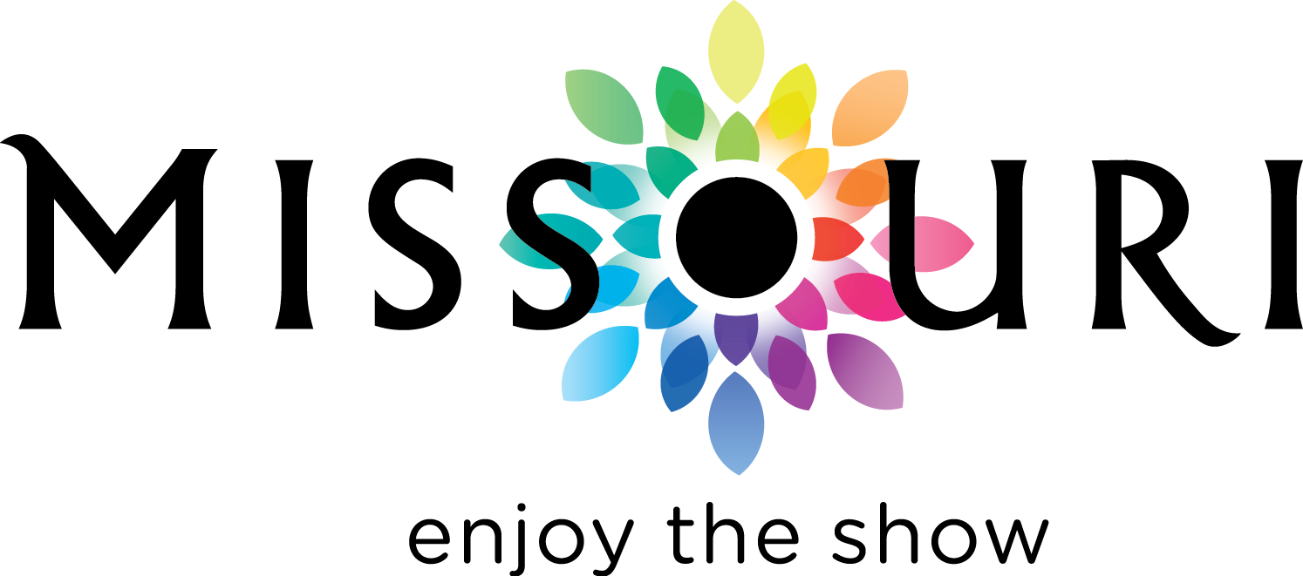

**2014-2018 STRATEGIC PLAN**

**MISSOURI DIVISION OF TOURISM**

**Updated June 2018**

**2014-2018 STRATEGIC PLAN FOR THE MISSOURI DIVISION OF TOURISM**

**Our Vision: To lead Missouri in becoming one of America’s most memorable tourist destinations.**

**Our Mission: To market tourism, increase revenue and deliver strong economic growth each year for the state of Missouri.**

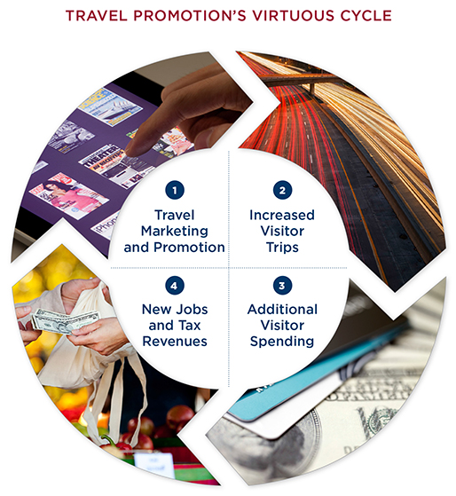

Tourism is one of the largest industries in the state of Missouri, generating $13.3 billion in tourism expenditures, $16.8 billion in economic impact and directly supporting more than 313,000 jobs. Wise and strategic investments in travel promotion feed a virtuous cycle of economic benefits. Travel promotion programs spur interest in visiting destinations among potential travelers. Stronger travel interest generates more visitors. Additional visitors spend more at local attractions, hotels, restaurants, retail stores and other businesses. Greater travel spending supports more local jobs and generates additional tax revenue for Missouri’s state and local governments.

As the official destination marketing organization charged with promoting Missouri as a travel destination, the Missouri Division of Tourism (MDT) plans and implements a wide variety of marketing, sales and communications initiatives, in order to maximize the economic impact of travel to the Show-Me State. The intent of this 2014-2018 Strategic Plan is to provide a framework within which MDT can identify, develop and execute programs to foster continued growth in the tourism industry.

**OUTCOMES**

* **Increase Tourism-Related Expenditures in Missouri**

*\*Measured by expenditures in 17 tourism-related SIC codes.*

* **Increase the Total Number of Visitors and Visitor Spending in Missouri**



**GOALS AND OBJECTIVES**

Goals and Objectives that support the above outcome measures have been established in five key areas:

* + Marketing and Communications
  + Collaboration, Partnerships and Leadership
  + Research
  + Organizational Effectiveness
  + Missouri Film Office

**MARKETING AND COMMUNICATIONS**

**GOAL: Position Missouri to effectively compete for travel and tourism market share using innovative marketing strategies**.

**Objective One:** Solidify the *Enjoy the Show* brand message across Paid, Earned, Owned and Social channels to build consistency in consumer perception.

**Objective Two**: Place integrated and targeted media in research-tested markets and audience segments that demonstrate a positive impact on visitation and visitor spending.

**Objective Three**: Increase awareness of the diversity of Missouri’s tourism assets and media- focused social media engagement through successful communications and public relations activities.

**Objective Four**: Expand the use of emerging technologies in order to locate our target audience in the consumer journey of dreaming, planning, taking and sharing travel experiences.

**Objective Five:** Enhance Missouri’s presence in group and international markets that have a strong likelihood to increase Missouri visitation (with a robust Canadian focus) through Brand USA partnerships and other targeted sales and communications efforts.

**COLLABORATION, PARTNERSHIPS AND LEADERSHIP**

**GOAL: Provide Strong Leadership for the Missouri Tourism Industry**

**Objective One**: Coordinate Missouri tourism industry marketing efforts by leveraging the state in its entirety at every media level possible through the Promote Missouri Fund Media Exchange Program, resulting in additional revenue for the state.

**Objective Two:** Continue to support the development of small, emerging destinations through the Collective Marketing Initiative and Marketing Platform Development programs.

**Objective Three**: Partner with the Missouri travel industry, Brand USA, Mississippi River Country, Travel South, and other destination marketing organizations to leverage investments in domestic and international marketing programs.

**Objective Four**: Develop opportunities with state agencies such as Missouri Arts Council, Missouri State Parks, Missouri Department of Conservation, Missouri Department of Natural Resources, Missouri Department of Agriculture, Missouri Wine and Grape Board, and Missouri Humanities Council, as well as tourism industry associations and the private sector on promotional projects.

**Objective Five:** Support the development and promotional objectives of tourism development organizations such as Highway 36, Old Trails, Route 66, and AgriMissouri.

**RESEARCH**

**GOAL: Provide timely, relevant and actionable research to MDT and industry partners**

**Objective One:**  Provide industry tourism and marketing research support through dissemination of cutting edge research, the Missouri Tourism Barometer and other actionable research tools.

**Objective Two:** Develop opportunities for DMO research partnerships.

**Objective Three:**Identify, through forward-looking research, the niche market segments that offer strongest opportunities for growth.

**Objective Four:** Continue to develop research projects that improve the evaluation of the efficiency and effectiveness of MDT marketing and communications efforts.

**ORGANIZATIONAL EFFECTIVENESS**

**GOAL: Enhance the Effectiveness of the Missouri Division of Tourism**

**Objective One:** Optimize informational partnerships with Missouri’s tourism industry by enhancing outreach efforts; sending MDT personnel out in the field to build partnerships with the industry; and interfacing with new DMO CEO and staff to familiarize them with MDT, its programs and its interest in partnership.

**Objective Two:** Provide legislators, other policymakers, and private sector partners the facts about the power of travel promotion when they are making decisions about budget priorities in order to secure adequate and stable funding for all strategic plan initiatives**.**

**Objective Three:** Develop more efficient ways of delivering cutting edge marketing services through staff education on procurement, processes and technologies.

**Objective Four**: Foster an enthusiasm for community networking by MDT staff by encouraging local community organization involvement, participation in industry activities, staff sharing of Missouri travel experiences with industry and visitors and partnership with communities at the Missouri State Fair and other statewide events.

**Objective Five:** Maintain a process for identifying and responding to potential crisis situations that affect Missouri tourism and deploy rapid response mechanisms, as necessary, to inform the industry and the public in such cases.

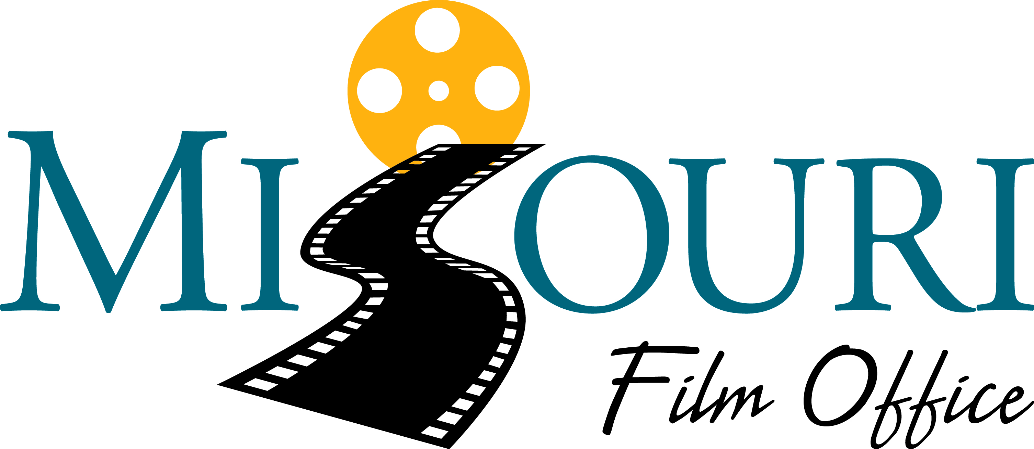

**MISSOURI FILM OFFICE**

**GOAL: Support the Missouri Film Office in becoming the hub of all film and creative media-related activity within the State**

**Objective One:** Support the Missouri Film Office in developing, coordinating and marketing the creative media industry in Missouri through increased online/social media communications, attendance/exhibition at industry trade shows, strong presence at regional film festivals, and support of film/digital media production programs at Missouri colleges and universities.

**Objective Two:** Assist the Missouri Film Office in content generation for the REEL-SCOUT state- wide database of skilled workers, special equipment operators and support service companies and the maintenance and marketing of the large photo and video database of diverse filming locations across the state.

**Objective Three:** Since productions that choose Missouri to shoot continue to need help through the process, work with Missouri Convention and Visitors Bureau staff to assist Missouri Film Office to set up and lead initial location scouting, assist/introduce city and state resources and provide subject matter expertise as needed.